Congregation Sukkat Shalom

Education Advisory Committee

High Holiday Guide

2015-5776



Rosh Hashanah is the Jewish New Year, a fall holiday that calls for both rejoicing and serious introspection. According to Jewish tradition, Rosh Hashanah is the birthday of the world and also the time of divine judgment. Rosh Hashanah is followed, ten days later, by Yom Kippur. Together these two days are called the High Holidays.

Leading up to Rosh Hashanah and throughout the holiday season themes of judgment and repentance, encouraging us to make amends for the wrongs we may have committed over the course of the previous year and set our ethical and spiritual path for the coming year.

Rosh Hashanah is observed both in the community and at home. Services are held in synagogues, with a special liturgy that emphasizes the themes of the holiday. In the midst of the liturgy you hear blasts from the shofar made from a ram's horn. The call of the shofar sounds reminds us to call out and change our lives for the better.  
  
Many people have the tradition, on the afternoon of Rosh Hashanah, to throw pieces of bread in a flowing body of water. The bread represents the sins, which we (hopefully) cast away on Rosh Hashanah. This ritual is called tashlich.

Many people gather for large family meals on Rosh Hashanah. A round challah replaces the normally braided bread, the circular shape symbolizing the eternal circle of life. The challah is traditionally dipped in honey, representing hopes for a sweet new year, as well as apples are dipped in honey for the same reason. Honey cakes and apple cake are common dessert.



Yom Kippur--the Day of Atonement--is a fast day that follows Rosh Hashanah. These two holy days are often called the High Holidays, and the in between them are known as the Ten Days of Repentance   
  
According to Jewish tradition, at the conclusion of Yom Kippur, God seals the Book of Life for the coming year. Yom Kippur is, thus, a day of prayer and introspection. It is considered the most solemn day on the Jewish calendar.  
  
The overarching theme of Yom Kippur is repentance. From the beginning to the end of the holiday, we are meant to be thinking about affecting positive change in our lives and making amends with others. In order to focus on the spiritual nature of the day, on Yom Kippur, we are instructed to separate ourselves from the mundane world. Traditionally, this means fasting--avoiding both eating and drinking—and abstaining from various other activities. Additionally, many people have the custom of wearing white on Yom Kippur, to symbolize the pure and clean way we hope to go into the New Year.

Services on Yom Kippur begin on the eve of the holiday with Kol Nidre, a prayer in which we nullify all vows we might make under duress in the year to come. Other additions to the liturgy are Yizkor, the memorial prayer, and the Viddui, the communal confession of sins.   
  
At the afternoon service we read the Book of Jonah and the day ends with a powerful service called Neilah, which imagines that the gates of heaven are closing at the end of the High Holiday period. Yom Kippur is concluded with a long loud blast from the shofar.



**Our High Holiday Traditions: Jill Schoeneman Parker**

Whenever the High Holidays arrive, we have the same thought… “What, how did they get here so fast”! Whether they are early in the fall, or later in the season, my husband and I are seemingly taken by surprise. We shouldn’t be. The dates are there on the calendar before us. But in the midst of the chaos of transition from summer to fall and the carefree days of camp to back school with homework and a busy schedule, the dates of these holidays stop me in my tracks. (Maybe these transitions parallel that week of creation… out of the sea of chaos comes heaven and earth, light and dark….)

I feel overwhelmed because I recognize *there is so much to do*. My husband smiles at me and tells me this is one of the things he loves about me. I feel this way at Passover, but for the reason of so much cooking. This holiday I feel it…. internally.

We use these holidays as a marker in our lives and to reflect upon accomplishments and noteworthy moments from the recent year. We also recognize how much more we each wished we had reached or grown. This is not a critical narrative, but merely our tradition of using these holidays as a spiritual wake up call to refocus and look at what really feels important. So, in the sea of transition, we try to carve out time to find some quiet and to think about the year to come reflect upon the past year and the many things for which we are grateful. My husband always approaches this in a list format while mine is more of a free flowing unfolding.

We always celebrate Rosh Hashanah with friends and family— there is always a brisket and roasted veggies and an apple dessert or two. For Break-fast for Yom Kippur, we always have blintze soufflé, bagels and lox, veggies, fruit, tuna salad--- a dairy based meal to eat after our fast. The hosting of holidays is really something we look forward to. It is a bit busy and a bit crowded, but no one cares. Everyone contributes and we all share summaries of “what our Rabbi talked about today”. Now that the kids are older (nearly 10 and 12), they can actually be helpful when they are helping! To them, they have never known not having this sort of holiday tradition. That is yet another thing for which we are so thankful. Happy Holydays!

A favorite apple dessert: Ina Garden’s Apple Crisp:

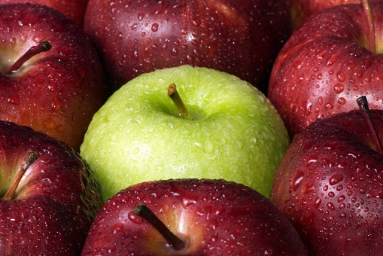

**Favorite Holiday Recipes**

Old-Fashioned Apple Crisp (03:15)

Total Time: 1 hr. 20 min

Prep: 20 min

Cook: 1 hr.

Yield: 10 servings

Level: Easy

Ingredients

5 pounds McIntosh or Macoun apples

Grated zest of 1 orange

Grated zest of 1 lemon

2 tablespoons freshly squeezed orange juice

2 tablespoons freshly squeezed lemon juice

1/2 cup granulated sugar

2 teaspoons ground cinnamon

1 teaspoon ground nutmeg

For the topping:

1 1/2 cups flour

3/4 cup granulated sugar

3/4 cup light brown sugar, packed

1/2 teaspoon kosher salt

1 cup oatmeal

1/2 pound cold unsalted butter, diced

Directions

Preheat the oven to 350 degrees F. Butter a 9 by 14 by 2-inch oval [baking dish](http://www.foodterms.com/encyclopedia/cookware-and-bakeware-materials/index.html).

Peel, core, and cut the apples into large wedges. Combine the apples with the zests, juices, sugar, and spices. Pour into the dish.

To make the topping, combine the flour, sugars, salt, oatmeal, and cold butter in the bowl of an electric mixer fitted with the paddle attachment. Mix on low speed until the mixture is crumbly and the butter is the size of peas. Scatter evenly over the apples.

Place the crisp on a [sheet pan](http://www.foodterms.com/encyclopedia/jelly-roll-pan/index.html) and bake for 1 hour until the top is brown and the apples are bubbly. Serve warm.

**Quick Apples & Honey Tart**

**Ingredients**

▪ 1 whole sheet of puffed pastry (I buy mine frozen and thaw a bit, not completely), cut into half or thirds

▪ 4 whole apples, cored, halved and sliced, but not peeled

▪ 1 cup brown sugar

▪ 1/4 teaspoon Salt

▪ Honey and powdered sugar, to taste

**Preparation Instructions**

Preheat oven to 415 degrees.

Place slightly frozen (but not brittle) puffed pastry rectangles onto a baking pan that’s been sprayed with nonstick spray or a light rub of canola, vegetable oil or butter. Add sugar and salt to apples. Stir to combine. Allow to sit for a few minutes. Arrange apple slices on the pastry rectangles in a straight line, overlapping as you go. Bake for 18 to 20 minutes, or until pastry is puffed and golden brown (check your pastry cooking instructions – if they differ, split the difference). You will know when it’s done when the apples and sugar are bubbly and the pastry is a beautiful golden brown. Remove from pan immediately and place on a serving platter. Serve with a drizzle of honey and a sprinkling of powdered sugar.

Kim Romaine

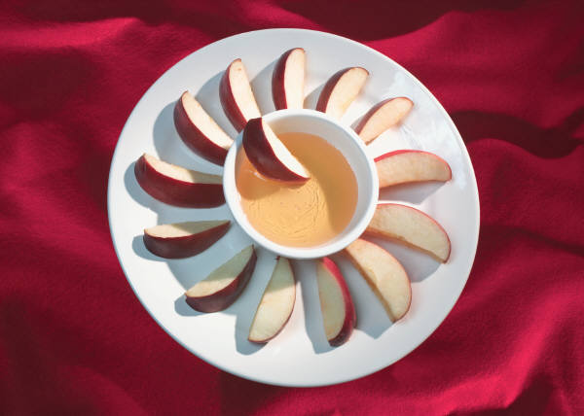

**Apple Dumplings**

2 cups water

1 ¼ cups sugar

½ teaspoon cinnamon

¼ cup butter

2 cups flour

½ teaspoon salt

1/3 cup butter

1/3 cup shortening

1/3 to ½ cup milk

2 tablespoons chopped nuts

1 tablespoon honey

2 tablespoons sugar

½ teaspoon cinnamon

6 small apples

1 tablespoon butter

1.     Preheat oven to 350 degrees. For sauce, in a saucepan, combine water, the 1 ¼ cups sugar, and the ½ teaspoon cinnamon. Bring to boiling, reduce heat. Simmer, uncovered, for 5 mins. Stir in the ¼ cup butter. Set aside.

2.     Meanwhile, for pastry, in a medium bowl combine flour and salt. Using a pastry blender, cut in butter and shortening until pieces are pea size. Sprinkle I tablespoon of the milk over the mixture; gently toss with a fork. Push moistened dough to side of the bowl. Repeat moistening dough, using a tablespoon of the milk at a time, until all the dough is moistened. Form dough into a ball. On a lightly floured surface. Roll dough to an 18x12 inch rectangle. Using a sharp knife, cut rectangle into 6 squares.

Evan Finamore

3.     In a small bowl combine the nuts and honey. In another small bowl stir together the 2 tablespoons sugar and the ½ teaspoon cinnamon. Set aside.

4.     Peel and core the apples. Place an apple on each square. Fill apple centers with nut mixture, sprinkle with sugar/cinnamon mixture. Moisten edges of each pastry square with water; gather corners over apples and pinch to seal. Place dumplings in a 13x9x2 inch baking dish. Reheat sauce to boiling and pour over dumplings. Bake, uncovered, about an hour or until apples are tender and pastry is golden. To serve, spoon sauce over dumplings.

(AWESOME served warm with vanilla ice cream!)

***We invite you to add your family traditions and recipes for Hanukkah, Passover and any others that you would like to share. Please send them to Alissa at azuchman@sukkatshalom.org***

**SHANA TOVA**

**שנה טובה**